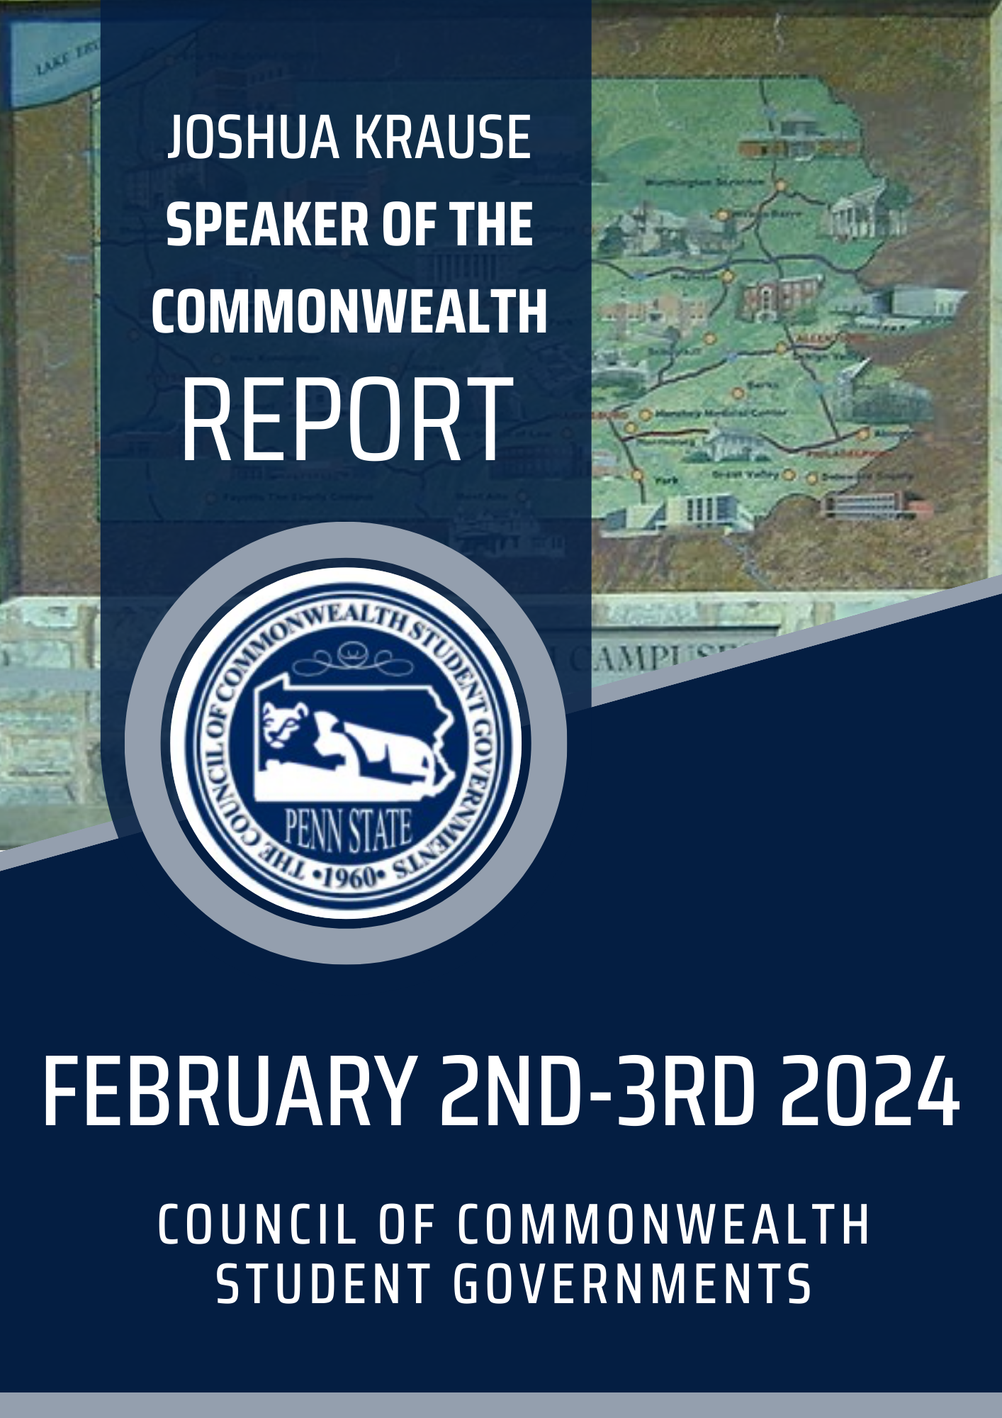

Table of Contents
Council Booklet 3
Dress Code & Overnight Stay 3
Location 3
Council Weekend Attendance 3
Food 4
General Tips for General Council Sessions 4
Be Seated Before Sessions Start 4
Robert’s Rules 4
Roll Call Procedure 5
Voting/Proxies 5
Committees 6
Parliamentary Procedure Guide 6
Personal Items/Expenses 6
Council Weekend Mindset 7
Closing 7

Council Booklet
The Council Booklet will be your reference for the February 2024 Council Weekend. It contains the itinerary, locations, agendas, speakers, and other helpful information. Please note that some of the sessions have specific instructions. The President's session, for example, is exclusively for Presidents and Vice Presidents who sit on council. No other attendees are permitted unless they have been approved by me prior to the session.

Dress Code & Overnight Stay
​​To maintain a professional atmosphere, we will follow a strict dress code for Council Weekend, with separate requirements for Friday and Saturday.
- Friday's dress code: Business casual attire such as dresses, khakis, slacks, black pants, dress shoes, polos, collared shirts, etc.
- Saturday's dress code: Business formal attire such as slacks, dress pants, black pants, skirts, dresses, blazers, or suits.
Please note that sneakers, ripped jeans, leggings, hoodies, sweatpants, and flip-flops are not considered professional wear.
Additionally, you will be arriving on Friday evening (before 6:45 PM or before 4:00 PM for CFB (Commonwealth Fee Board) members) and staying overnight until Saturday evening. Please pack accordingly and plan to arrive early to allow enough time for check-in at your hotel. We look forward to seeing you there!

Location
If you are attending the upcoming council at University Park (UP), it is important to know that the meetings will be held in the HUB. The Council Weekend booklet contains a map of UP that can help you locate the HUB. You can also find all the details regarding the location of all meetings in the booklet. It is worth noting that parking is available at the HUB Parking Deck, which is highlighted on the map at the end of the booklet. However, it is important to mention that CCSG will not pay for parking fees.

Council Weekend Attendance
CCSG Council weekends are exclusively for the Penn State community (students, staff, and faculty), and outside members may only attend if invited by the President or myself. As the Parliamentarian (and by default, the Sergeant-at-Arms), I have the authority to remove individuals from the session or council in its entirety, if deemed necessary.

Food
Dinner will not be provided Friday night. Breakfast and coffee will be provided for Council Members during the Saturday morning President's session. I would recommend your delegation to plan to get breakfast or utilize the complimentary breakfast offered by your hotel (if the hotel offers it). Lunch will be provided by CCSG on Saturday, and there will be different options to accommodate diets. Your President and Vice President should have submitted your food accommodations prior to the Council Weekend. If so, there will be food options that satisfy your needs.

General Tips for General Council Sessions

Be Seated Before Sessions Start
To ensure a smooth and timely council session, kindly make sure that all your delegation is seated in the gallery of the council room before I call the session to order. Please note that only council members or proxies approved by me are allowed to sit at the council tables.

Robert’s Rules
To ensure an organized and productive council meeting, please follow the established procedure:
- Only seated council members are allowed to speak unless a council member yields the floor to someone in the gallery.
- Motions can only be proposed by a council member.
Remember to adhere to Roberts Rules for proper meeting etiquette.
Council Members will be receiving a guide to parliamentary procedure for reference.
As Speaker of the Commonwealth, I will serve as the parliamentarian to General Council Sessions.

Roll Call Procedure
During roll call, our Executive Secretary will call your campus, and one of the council members present will indicate the campus name and number of council members present from your delegation.

Voting/Proxies
If you are a President or Vice President, you hold exclusive voting rights for your campus. If you are unable to attend council and are sending a representative (proxy) in your place, I must be informed of their name 24 hours prior to the council. (Exceptions may be made in extraordinary circumstances, which will be assessed on a case-by-case basis.) If proxy names are not provided, and an individual shows up claiming to be of your delegation, I reserve the right to deny their participation. Please adhere to council regulations and inform us if you cannot attend.

Guidelines for Speaking During Meetings
If you would like to speak during a meeting, please follow these simple steps:
- Raise your hand so that I can see it and call on the first raised hand.
- When called upon, state your name and campus before proceeding.
- After speaking, it is important to yield the floor back to me. Simply state, "I yield the floor back to the Speaker."
As Parliamentarian, I must prioritize speakers who have not yet spoken and will avoid calling on someone repeatedly right away.
If you are unsure about the procedure or what is happening regarding the current matter, please interrupt me and say, "Point of Inquiry or Point of Parliamentary Inquiry, Mr. Speaker."
Point of inquiry is for general questions.

Motions
All motions must have a second.
I will announce what quorum is for passing motions at the beginning of each council session, so everyone is aware.

Respectfulness
Engaging in civil debate is a crucial aspect of effective communication, particularly in a professional setting. It allows individuals to express their opinions and ideas while still respecting the views of others.
When participating in a debate, it's essential to remain open-minded and receptive to the perspectives of others. Even if you disagree with someone, listening to their point of view can help you better understand their position and potentially find common ground.
Asking questions is a valuable way to clarify information and gain a deeper understanding of a topic. Don't be afraid to ask questions, even if they may seem basic or obvious. Chances are, if you have a question, others in the group may have the same question as well.
It's important to remember that the goal of a General Council session is not to "win" or convince others that your opinion is the only correct one. Rather, it's an opportunity to exchange ideas and learn from one another. Keeping this in mind can help foster a more productive and respectful debate.

Committees
Guidelines for General Council Sessions will be applied to committee sessions, but with a greater degree of flexibility to encourage open dialogue and the exchange of ideas. Keep in mind that Robert's Rules must be adhered to in order to pass official changes or adopt resolutions within the committee.

Parliamentary Procedure Guide
Attached is a document named "Adopted Parliamentary Procedure" that outlines some motions that may be useful. However, please note that not all of these motions may be recognized or used during our sessions as we are a Student Government, and we want to avoid confusing those in attendance.

Personal Items/Expenses
Remember to bring a refillable water bottle, phone charger, or any other personal items you may need this weekend. Also, I would suggest bringing cash and cashless forms of payment for any personal expenses. Please note that the hub dining areas and other places at UP do not take cash. Some areas downtown do, but not all.

Council Weekend Mindset
Keep your expectations wide and be open to anything this weekend! There are so many opportunities and connections you will make at CCSG, and it's important to make the most of it. Remember, everything you put in is what you get out.

Closing
I am beyond excited for the kickoff of the spring semester of 2023-24 academic year with the February Council and can't wait to see you all there. Although we're excited to meet in person, please remember that COVID is still a concern, so let's prioritize our safety. If you're a council member and can't attend due to COVID, please work with me to arrange a proxy. If you have any questions about this weekend or the packet, don't hesitate to contact me at jtk5570@psu.edu. Be sure to review the resolutions and other materials included in the email sent to all Council Members and posted on Teams. See you all soon!

