

CCSG

October 2017 council

“To promote unity, change, and growth throughout the Commonwealth”

|  |  |  |  |  |  |  |  |  |  |
| --- | --- | --- | --- | --- | --- | --- | --- | --- | --- |
| table of Contents | | | | | | |  |  |  |
| Agendas/Inforamtion | | |  | | | | |  |  |
|  | | Council Agenda | | | | | |  | 2 |
|  | | Where and When | | | | | |  | 3 |
|  | | Map of University Park | | | | | |  | 4 |
|  | | Parking Information | | | | | |  | 5 |
|  | | Student Affairs | | | | | |  | 6 |
|  | | Governmental Affairs | | | | | |  | 7 |
|  | | Governmental Affairs Document | | | | | |  | 8 |
|  | | Academic Affairs | | | | | |  | 9 |
|  | | Student Conflict Management Ad-Hoc | | | | | |  | 10 |
|  | | Public Relations Ad-Hoc | | | | | |  | 11 |
|  | | Women in Leadership Ad-Hoc | | | | | |  | 12 |
|  | | Speaker Introductions | | | | | |  | 13 |
| Legislation | | | |  | | | |  |  |
|  | How to review legislation | | | | | | |  | 14 |
|  | | | | | | | | | |  |
|  | | | | |  |  | | |  |

**October Council Agenda**

Penn State University Park

October 6th – 7th, 2017



|  |  |  |  |
| --- | --- | --- | --- |
| **Time** | **Item** | **Member** | |
| *Friday, October 6th, 2017* | | | |
| 7:00 – 8:00pm | Presidents’ Session1 | Taylor | |
| ***Council*** | | | |
| 8:15 | Call to Order / Roll Call | Sedhom/Nygard | |
|  | Approval of Minutes / Agenda | Sedhom | |
|  | President’s Welcome Taylor | |  |
| 9:00pm | Adjournment | Sedhom | |
| ***Meetings*** | | | |
| 9:10 - 10:10pm | Committee Meetings | Director | |

|  |  |  |  |  |  |  |
| --- | --- | --- | --- | --- | --- | --- |
| **Time** | | **Item** | | | | **Member** |
| *Saturday, October 7th, 2017* | | | | | | |
| 8:30- 10:00am | | Presidents’ Session1 | | | Taylor | |
| ***Council*** | | | | | | |
| 10:15 | | Reconvene / Roll Call | | | Sedhom/Nygard | |
|  | | UPUA Report | | | Karafilis | |
|  | | GPSA Report  Faculty Senate Report | | | Hoeschele | |
|  | | Board of Trustees Report | | | DeBellis | |
| 10:45am | | Adjournment | | | Sedhom | |
| ***Meetings*** | | | | | | |
| 11:00 - 12:00pm | | Committees | | | Director | |
| ***Lunch*** | | | | | | |
| 12:10 - 1:10pm | | Lunch | | |  | |
|  | | Constitutional Review Committee2 | | |  | |
| ***Meetings*** | | | | | | |
| 1:15 – 2:15pm | | Ad-Hoc Committees | | | Director | |
| 2:30 - 3:30 | | Committee Meetings | | | Director | |
| ***Council*** | | | | | | |
| 3:40 | | Reconvene / Roll Call | | | Sedhom/Nygard | |
|  | | Old Business | | | Taylor | |
|  | | New Business | | | Taylor | |
|  | | Open Forum | | | Sedhom | |
|  | | Closing Comments | | | Taylor | |
| 4:15pm | | Adjournment | | | Sedhom | |
|  | |  | | |  | |
|  | |  | | |  | |
| Where and When?  ***HUB-Robeson Center*** | | | | | | |
| **Item** | | | **Room** | **Time** | | |
| *Friday, October 6th, 2017* | | | | | | |
| Presidents’ Session1 | | 102 | 7:00 – 8:00pm | | |
| Council | | 233AB | 8:15 – 9:00pm | | |
| Student Affairs Committee | | 327 | 9:10 - 10:10pm | | |
| Governmental Affairs Committee | | 325 | 9:10 - 10:10pm | | |
| Academic Affairs Committee | | 330 | 9:10 - 10:10pm | | |
| *CCSG Office* | | *312/313 HUB* |  | | |
| *Saturday, October 7th, 2017* | | | | | | |
| Presidents’ Session1 | | 102 | 8:30 - 10:00am | | |
| Council  Academic Affairs Committee  Governmental Affairs Committee  Student Affairs Committee | | Alumni Hall  330  229  322 | 10:15 - 10:45am  11:00 - 12:00pm  11:00 - 12:00pm  11:00 - 12:00pm | | |
|  | |  |  | | |
| Lunch | | Alumni Hall | 12:10 - 1:10pm | | |
| CRC2  Student Conflict Ad-Hoc  Public Relations Ad-Hoc  Women in Leadership Ad Hoc | | 106  106  107  322 | 12:10 - 1:10pm  1:15 - 2:15pm  1:15 - 2:15pm  1:15 - 2:15pm | | |
| Academic Affairs Committee | | 330 | 2:30 – 3:30pm | | |
| Governmental Affairs Committee | | 229 | 2:30 – 3:30pm | | |
| Student Affairs Committee | | 322 | 2:30 – 3:30pm | | |
| Council | | Alumni Hall | 3:40 – 4:15pm | | |

1 Presidents’ Session is for SGA Presidents and Vice Presidents only, please bring your new Presidents and Vice Presidents to Saturday morning session.

2 Constitutional Review Committee is for committee members only.

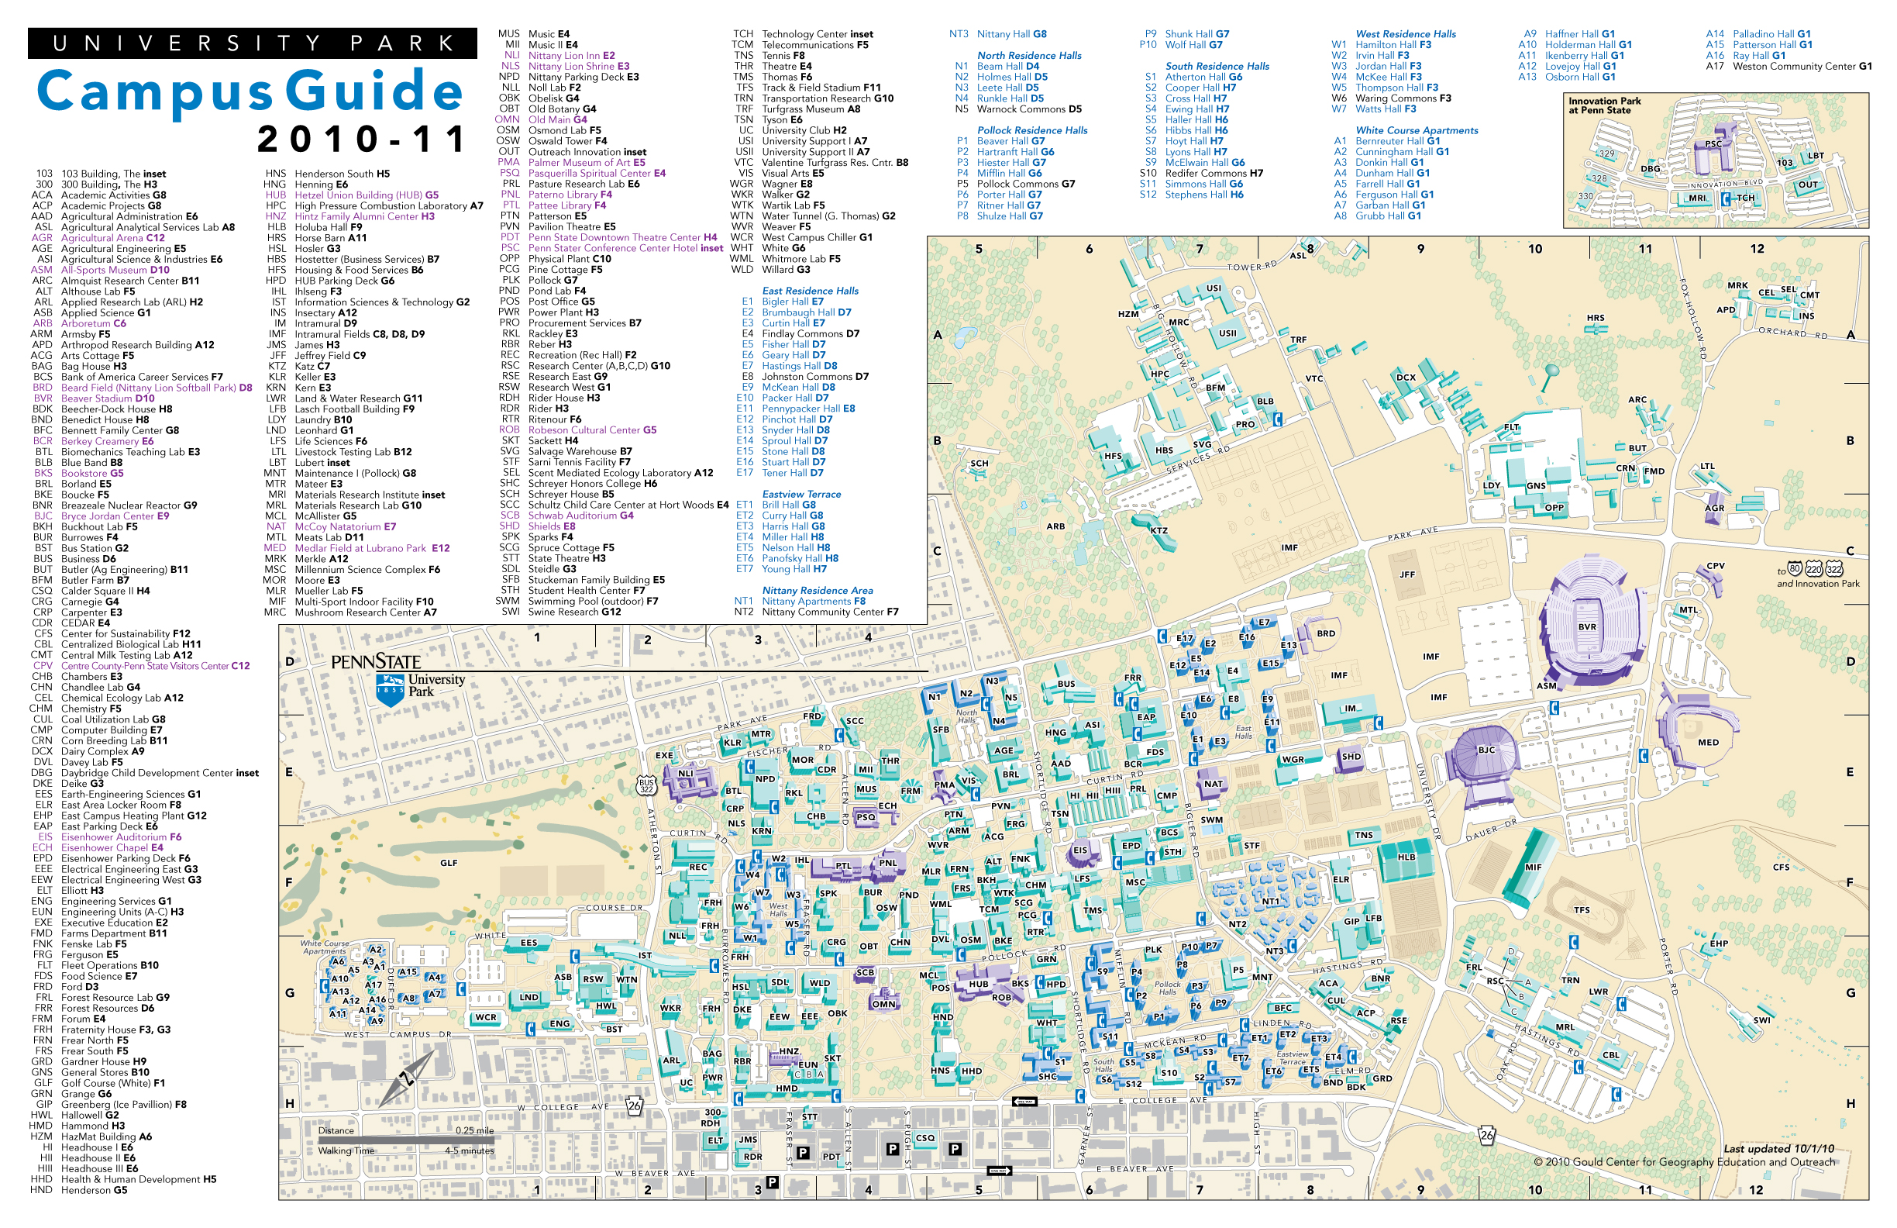

Parking Information

**Parking:**  Parking is available in the picture below and on the following page; there are several parking decks on and off campus. Friday parking on campus is $1 per hour if you are in the HUB deck after 4:00 pm; off campus rates vary per hour. Saturday on campus parking is free.



**Student Affairs Committee**

**Director: Barbara Awad (bxa5160@psu.edu)**

**A****ssociate Directors: Adele Smith (aks5753@psu.edu)**

**John Saad (jfs5516 @psu.edu)**

|  |  |  |
| --- | --- | --- |
| Friday, October 6th, 2017 | | |
| Time | Item | Member |
| 9:10 pm | Call to Order | Awad |
| 9:15 pm | Introductions | Awad/Smith/Saad |
| 9:30 pm | CCSG Expectations | Awad/Smith/Saad |
| 9:40 pm | Commonwealth Expectations | Awad/Smith/Saad |
| 9:50 pm | Student Affairs Initiatives | Awad |
| 10:00 pm | Questions | Awad |
| 10:10 pm | Adjournment | Awad |

|  |  |  |
| --- | --- | --- |
| Saturday, October 7th, 2017 | | |
| Time | Item | Member |
| 11:00 am | Call to Order | Awad |
| 11:05 am | Barry Bram: Senior Director of Student Engagement Programs | Bram |
| 11:50 pm | Questions | Awad |
| 12:00 pm | Adjournment | Awad |

|  |  |  |
| --- | --- | --- |
| Saturday, October 7th, 2017 | | |
| Time | Item | Member |
| 2:30 pm | Call to Order | Awad |
| 2:35 pm | Student Affairs Initiatives | Awad/Smith/Saad |
| 2:40 pm | Discussion about Common Hour | Awad/Smith/Saad |
| 2:55 pm | November Council (DSA’s Info) | Awad |
| 3:15 pm | Questions | Awad |
| 3:20 pm | Closing | Awad |
| 3:25 pm | Adjournment | Awad |

**Governmental Affairs Committee**

 **Director: Dave Stewart (dfs5215@psu.edu)**

**Associate Director: Riley Cagle (rgc5109@psu.edu)**

|  |  |  |  |
| --- | --- | --- | --- |
| Friday, October 6th, 2017 | | | |
| Time | Item | Member | |
| 9:10 pm | Call to Order | Stewart | |
| 9:15 pm | Introductions of Director/Associate | Stewart/Cagle | |
| 9:25 pm | Central Staff Transitional Information | Stewart | |
| *9:30 pm* | Explanation of mission | Stewart | |
| 9:40 pm | Previous work-Summer | Cagle | |
| 9:50 pm | Expectations of Campuses | Stewart/Cagle | |
| 10:00 pm | Questions | Stewart | |
| 10:10 pm | Adjournment | Stewart | |
|  |  |  | |
| Saturday, October 7th, 2017 | | | |
| Time | Item | Member | |
| 11:00 am | Call to Order | Stewart | |
| 11:05 am | Presentation by Zack Moore (Vice President of Government and Community Relations) | Speaker-Zack Moore | |
| 11:35 am | Questions | Speaker-Zack Moore | |
| 11:45 pm | Updates from Campuses | Stewart | |
| 12:00 pm | Adjournment | Stewart | |
|  |  |  | |
| Saturday, October 7th, 2017 | | |
| 2:30 pm | Call to Order | Stewart | |
| 2:35 pm | Explanation of breakout | Cagle | |
| 2:40 pm | Contact Reps & Senators | Stewart | |
| 3:00 pm | Drive to strive discussion | Stewart | |
| 3:15 pm | Final questions | Stewart | |
| 3:25 pm | Adjournment | Stewart/Cagle | |

**Governmental Affairs House Rep/Senate Document**

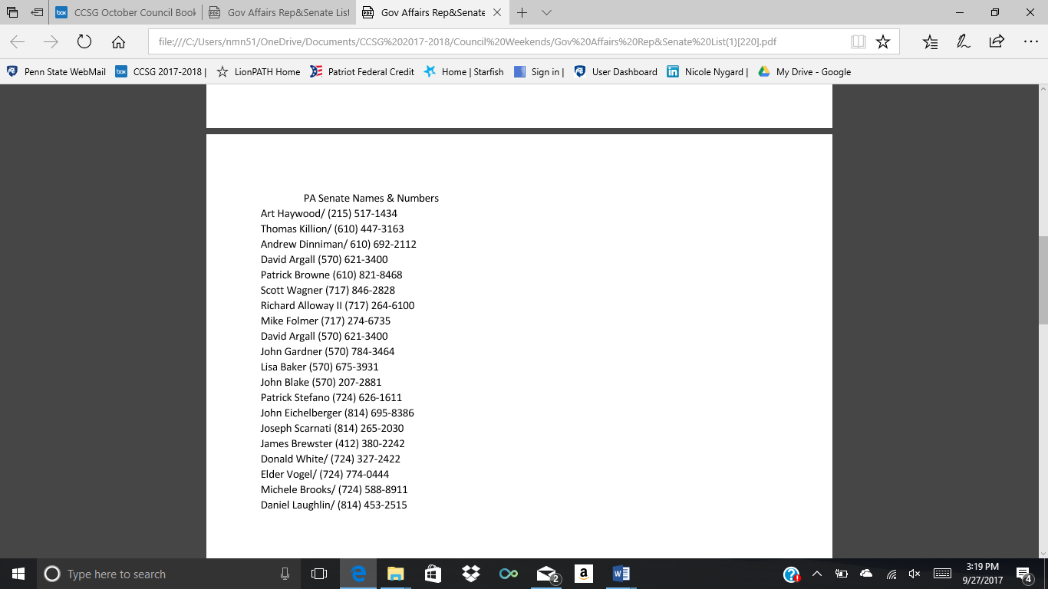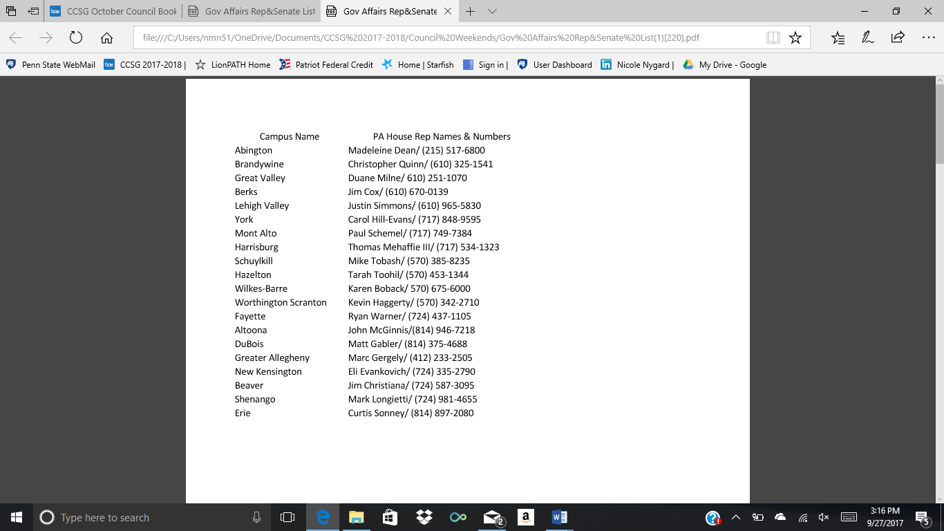

**Academic Affairs Committee**

**Director: Brit Ickes (bai5038@psu.edu)**

**Associate Director: David D. Antonio (dmd5942@psu.edu)**

|  |  |  |
| --- | --- | --- |
| Friday, October 6th, 2017 | | |
| Time | Item | Member |
| 9:10 pm | Call to Order | Ickes |
| 9:20 pm | Introductions | Ickes/D’Antonio |
| 9:30 pm | CCSG Academic Affairs Expectations | Ickes/D’Antonio |
| 9:40 pm | SGA Academic Affairs Expectations | Ickes |
| 9:50 pm | Years Agenda (Intro. to surveys) | D’Antonio/Ickes |
| 10:00 pm | Individual Surveys | Ickes |
| 10:10 pm | Adjournment | Ickes |
|  |  |  |
| Saturday, October 7th, 2017 | | |
| Time | Item | Member |
| 11:00 am | Call to Order | Ickes |
| 11:10 am | Intro to Surveys | Ickes |
| 11:25 am | Survey Do’s & Do nots | Ickes |
| 11:30 am | Plan of action | Ickes |
| 11:45 am | Adviser Incentives | D’Antonio |
| 12:00 pm | Adjournment | Ickes |
|  |  |  |
| Saturday, October 7th, 2017 | | | |
| 2:30 pm | Call to Order | Ickes |
| 2:33 pm | Continue Student Surveys | Ickes |
| 2:35 pm | Template | Ickes |
| 2:50 pm | Collection | Ickes |
| 3:10 pm | Compilation | Ickes |
| 3:20 pm | Adviser Incentives | D’Antonio |
| 3:30 pm | Adjournment | Ickes |

**Student Conflict Management Ad Hoc**

**Director: Ann-Queen Sedhom (ams7897@psu.edu)**

|  |  |  |
| --- | --- | --- |
| Saturday, October 7th, 2017 | | |
| Time | Item | Member |
| 1:15pm | Call to Order | Sedhom |
| 1:18pm | Group Activity | Sedhom |
|  | Define Conflict | Sedhom |
| 1:43pm | How to evaluate conflict | Sedhom |
|  | Organizational vs. Personal | Sedhom |
|  | Does it affect your mission | Sedhom |
| 1:55pm | How to resolve conflict | Sedhom |
|  | When it is time to seek mediation | Sedhom |
| 2:00pm | Moving forward | Sedhom |
| 2:05pm | Summary and Questions | Sedhom |
| 2:15pm | Adjournment | Sedhom |

**Public Relations Ad Hoc**

**Director: Andres Zabala (aez5059@psu.edu)**

**Associate Director: Camden Hadleman (cmh6174@psu.edu)**

**Associate Director: Greg Peter (glp5081@psu.edu)**

|  |  |  |
| --- | --- | --- |
| Saturday, October 7th, 2017 | | |
| Time | Item | Member |
| 1:15pm | Call to Order | Zabala |
|  | Social Media Etiquette | Zabala |
|  | Setting up and Working a YouTube Page | Handleman |
|  | Effective Websites | Peter |
|  | Managing Your Unit | Zabala |
| 2:15pm | Adjournment | Zabala |

**Women in Leadership Ad Hoc**

**Director: Hunter DeBellis (hsd5031@psu.edu)**

|  |  |  |
| --- | --- | --- |
| Saturday, October 7th, 2017 | | |
| Time | Item | Member |
| 1:15pm | Call to Order | DeBellis |
| 1:20pm | Introduction for Andrea Dowhower, AVP for Student Affairs | DeBellis |
| *1:50pm* | Questions | DeBellis |
| 2:15pm | Adjournment | DeBellis |

**Speaker Biographies**

|  |
| --- |
| Governmental Affairs Speaker |

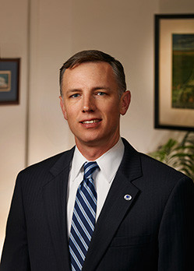

**Zack Moore: *Vice President of Government and Community Relations***

Zack Moore started his career at Penn State in 2007, bringing experience in both the U.S House and Senate. As the Vice President of Government and Community Relations, Zack communicates to elected officials the value that Penn State provides to the residents of PA. While at Penn State, Zack has become a passionate supporter of Penn State’s land-grant mission. Originally, before coming to Penn State, Zack began on Capitol Hill working for members of the U.S Senate and House of Representatives. He served as the Legislative Director for the United States Senator Rick Santorum. Zack Moore graduated Penn State with his bachelor of arts degree in International Politics and currently lives in State College with his wife and kids.

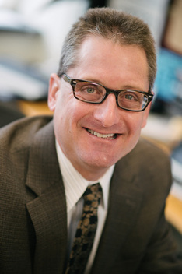

|  |
| --- |
| Student Affairs Speaker |

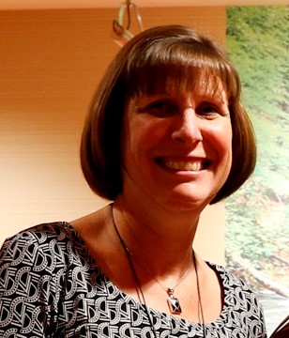

***Andrea Dowhower: Assistant Vice President of Student Affairs***

Andrea Dowhower has years of experience working in various universities such as University of Maryland, Susquehanna University and Ohio State University. For three years she was the Director of Student Affairs Assessment at Ohio State University. In 2004 an even greater opportunity arose at Penn State and she has been here ever since! She started as the Director for Student Affairs Research and Assessment and remained in that position for about 5 years, but is now the Assistant Vice President of Student Affairs. Andrea has degrees from Muhlenberg College, Ohio State University, and Penn State University.

**Barry Bram: *Senior Director of Student Engagement Programs***

Barry Bram is the former adviser for a largely recognized Penn State organization, THON. He started as the THON advisor in 2007 and decided to step down from the position in 2013. He is also an advocate for State of State; he was one of their community speakers in 2015. He has been a part of the Penn State community for over 20 years now. He has worked in Residence Life, Student Conduct (Judicial Affairs), and Union and Student Activities.  He is originally from Lyndhurst, Ohio, and has degrees from Miami University and The University of Vermont. ﻿

|  |
| --- |
| Women in Leadership Ad-Hoc Speaker |

How to Read Legislation

C.R. = Council Resolution

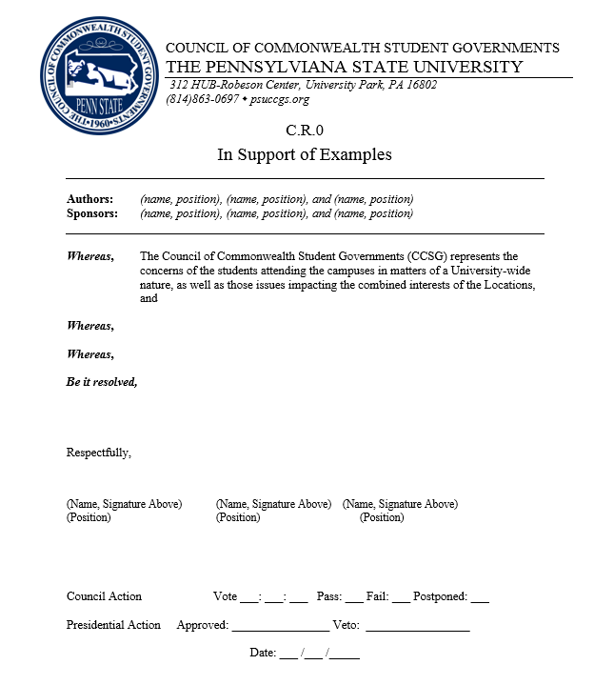

What are we in support of (aka - the title)

Author = who wrote the legislation

Sponsor = any student who is committed to the legislation

The body of the legislation

Author(s) signature(s)

Council’s official vote